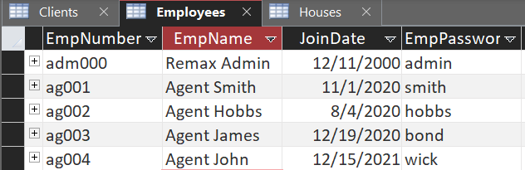
ag* - Agents
EmpNumber = Username
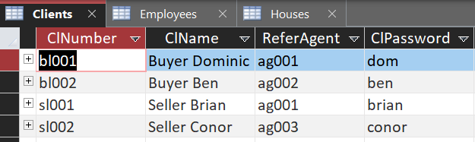
bl* - Buyers
sl* - Sellers
ClNumber = Username

hs* - Houses

